NOVEXCOMM 3U DUAL DIGITAL QSL CAROUSEL DISPLAY
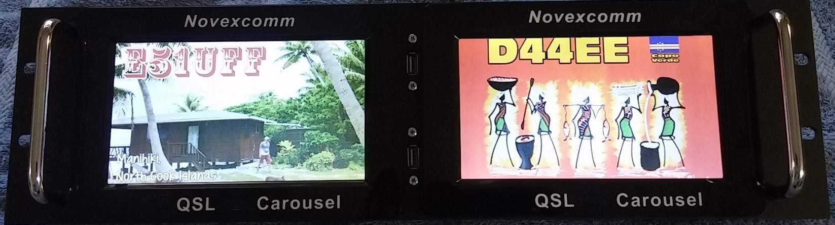
3U PANEL FITS RIGHT IN YOUR SHACK RACK
ON BOARD 2GB MEMORY HOLDS A TON OF QSL CARDS
EVEN HAS AUDIO & MOVIE ABILITY…BUT WHY?? ()
FRONT-PANEL USB UPLOAD WITH 3 KEYSTROKES OF THE FULL-FEATURED IR REMOTE CONTROLLER:
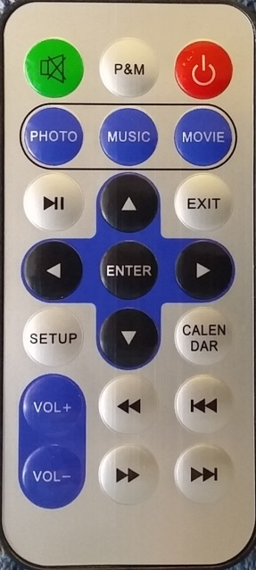
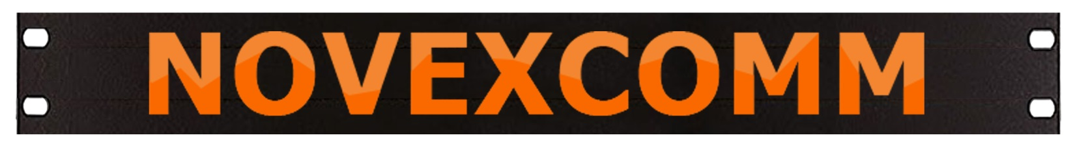
Visit www.Novexcomm.com or call 310.534.4456 to order yours TODAY!

