NOVEXCOMM CLOCK/ VOLTAGE/ TEMPERATURE METER PANEL
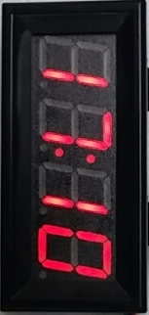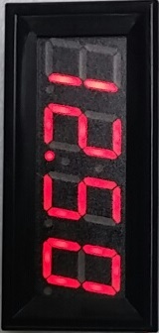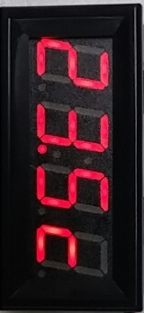
1U RACK PANEL WITH 2 METERS & “ON THE AIR” IN RED BACKLIGHT
UTC/ LOCAL TIME, DC VOLTS & DEGREES CELSIUS DISPLAY
ALL 3 CYCLE DISPLAY OR FIX ON ONE OF THEM AS NEEDED
ORDER YOURS CUSTOM BUILT WITH YOUR CALL SIGN CENTERED
SETTING INSTRUCTIONS: MODE ON LEFT, SET ON RIGHT BUTTON
Mode setting button:
Short press to select the clock, seconds, voltage, temperature display mode for one specific display OR:
Long press to show “ALL”, Enter the time temperature voltage alternating display mode, interval of 5 seconds with a Short press to EXIT
SET Time setting button:
Short press to adjust the hours, minutes (flashing), Short press again to exit
Short press the "Mode setting button", the clock starts running (full colon symbol flashes once per second)
Red = + DC source from 7-20 VDC, Black = Negative
Green = + lead to attach to your battery/ power supply for DC metering
Long black lead is the thermistor; put one on the rig PA final amplifier and one in open-air to watch the temperature differential from ambient
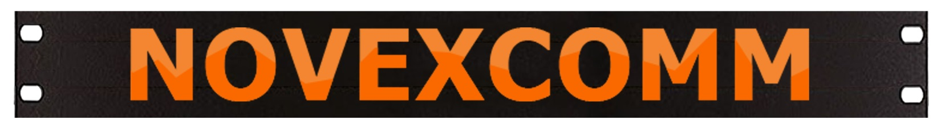
Visit www.Novexcomm.com or call 310.534.4456 to order yours TODAY!

